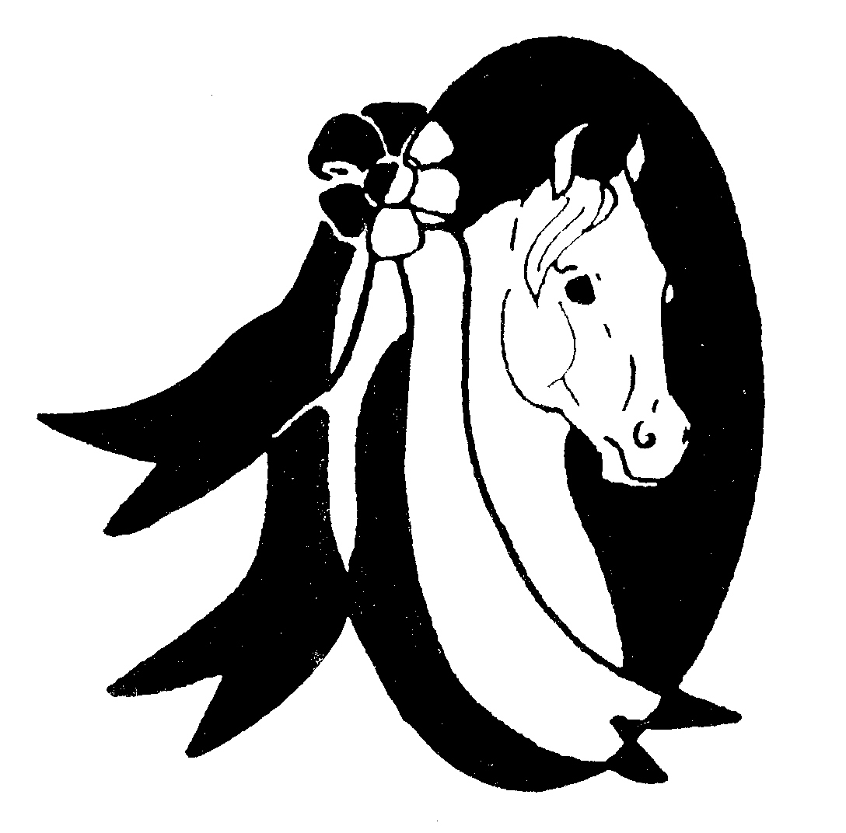
Inter-County Horsemen’s Association
Celebrating 72 years
1948-2020

Dear ICHA Member,

Thank you for joining the 2020 show season. Enclosed is your membership card.
We offer affiliated horse shows, where you as a member will qualify for the year end Awards Program.

For members to qualify for yearend awards, the following information is important to you:
- Owner and Rider must be a current dues paying member of ICHA
- Horses/Ponies must be nominated on the 2020 application
- The nominated horse/pony must show at 3 affiliated horse shows (find shows at www. i-cha.org)
- The nominated horse/pony must earn at least 10 points:
 | First | Second | Third | Fourth | Fifth | Participation
Regular | 6 | 5 | 4 | 3 | 2 | 1
Champion | 11 | 9 | 7 | 5 | 3 | 1

***If you attend a Double Point Horse Show (points x 2) Triple Point Show (points x 3) ***
Reminder, unadvertised class additions to a show schedule will not count toward point accumulations.

Thank you for considering ICHA and hope you have a safe and successful show season!
Whether you ride, drive, show for points or just for fun, ICHA thanks you.

Sincerely,
Amy Braden
ICHA Point Secretary
3990 Boardman Street
New Waterford, OH 44445
hoofsnharmony@yahoo.com
330-692-3283

